## the fastest way to relieve stress

There are countless techniques for managing stress.

Yoga, mindfulness meditation, and exercise are just a few examples of stress-relieving activities that work wonders.

But in the heat of the moment—during a high-pressured works, you may not have change to excuse yourself to meditate or take a long walk.

For these situations, you need something more immediate and accessible.

One of the speediest and most reliable ways to stamp out stress is by engaging one or more of your senses—sight, sound, taste, smell, touch—or through movement.

But since everyone is different, you’ll need to do some experimenting to discover which technique works best for you.

### Sight



* Use a plant or flowers to enliven your work space.



* Enjoy the beauty of nature—a garden, a lake, a park, or your own backyard.



* Surround yourself with colors that lift your spirits.



* Close your eyes and picture a place that feels peaceful



### Smell



* Light a scented candle or burn some incense.

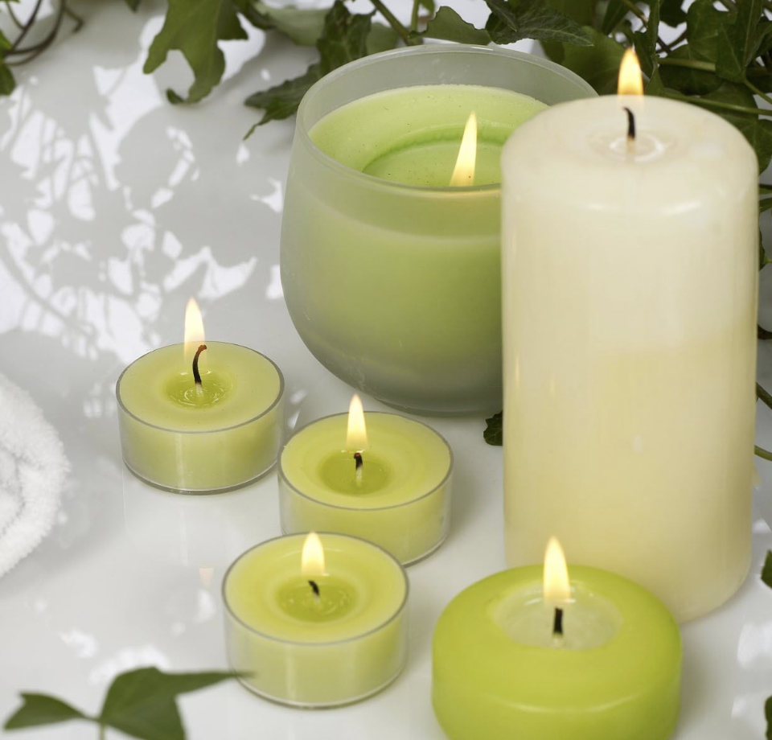

* Experiment with different essential oils.



* Smell the roses—or another type of flower.



* Enjoy clean, fresh air in the great outdoors.



### Touch



* Wrap yourself in a warm blanket.



* Pet a dog or cat.



* Wear clothing that feels soft against your skin.



### Taste

  
Slowly savoring a favorite treat can be very relaxing, but mindless eating will only add to your stress and your waistline. The key is to indulge your sense of taste mindfully.

* Chew a piece of sugarless gum.

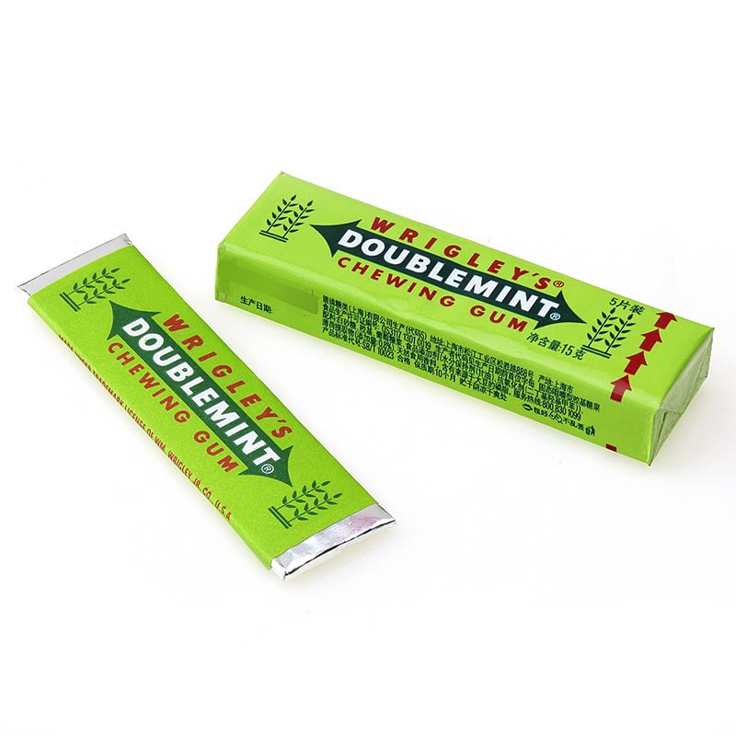

* Indulge in a small piece of dark chocolate.



* Eat some fruits



### Movement



If you tend to shut down when you’re under stress, get you moving may be particularly helpful.

* Run in place or jump up and down.



* Stretch or roll your head in circles.



* Go for a short walk.



### Sound



* Sing or hum a favorite tune.



* Listen to some light music.



**The examples listed above are intended to be a jumping-off point.**

**Let your mind run free and come up with additional things to try.**

**When you find the right sensory technique, you’ll know it!**